.NET CORE
what is?
it is cross platform high performanace ,open source, framework for buliding modern,cloud based,internet connected application.
Benefits or why?
1.asp.net core applications can run and developed on different applications like ;
windows
mac
os
2.asp.net core can be hosted on
iis
apache
docker
self hosted in your own process
3.one programming model for MVC and Web API
4.Dependency Injection
5.Testability : unit testing is very easy
6. Open source

what is dot net core?
Why?
What is web api?
How to create project of dot net core?
middleware
buliding block of an application life cycle
these are series of pipeline combined to form in any one of the httpd request
differnce between dot net core and dot net entity framework
life cycle for dot net core web api life cycle

And about the files
Target Framework:
it will show the TFM(target framework monica) like for this what is the ver we are selected
aspnetcorehostingmodel:
specifies how the applications hosted like inprocess or outofprocess
Inprocess hosts the app inside the IIS worker process(w3wp.exe)
outofprocess hosting model forward web requests to backend ASP.NET core app running the kestrel server
Package reference:
includes the references to the nuget packages that is installed for the appication

In process Hosting:
<aspnetcorehostingmodel>Inprocess</aspnetcorehostingmodel>
createdefaultbuilder() method calls UseIIS() method and host the app inside the IIS worker process
(w3wp.exe or iisexpress.exe)

outofprocess hosting:
2web servers-Internal and external web servers-Internal
Internal web server is kestrel
external web server is IIS
what is kestrel?
1.cross platform web server for asp.net core
2.kestrel can be used by itself an edge servers-Internal
3.the process used to host the app is dotnet.exe
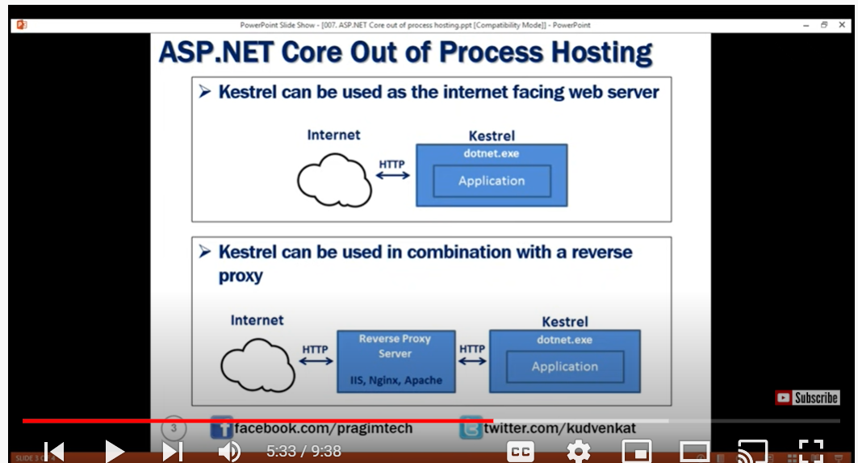

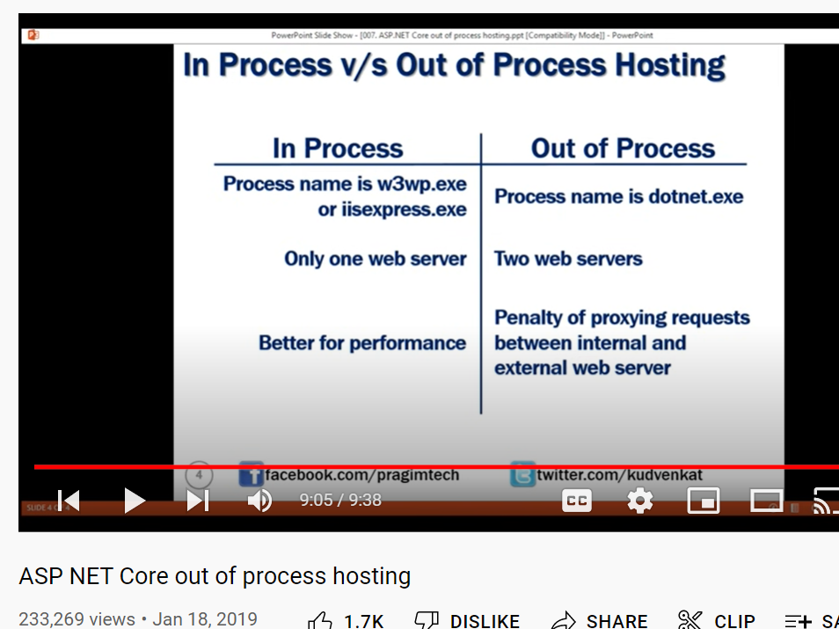

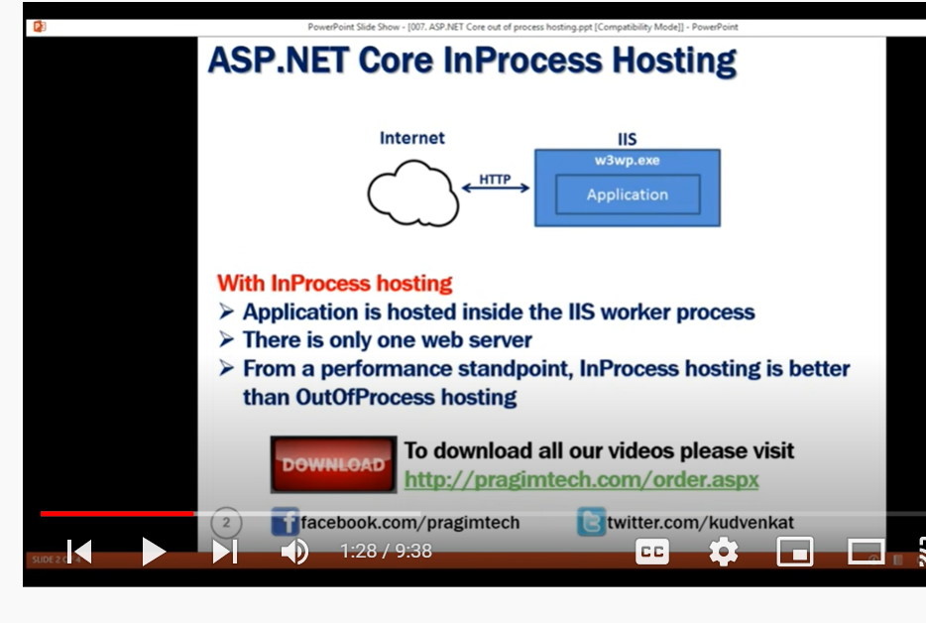https://www.tutorialspoint.com/what-is-kestrel-and-how-does-it-differ-from-iis-asp-net#:~:text=The%20main%20difference%20between%20IIS,and%20maintained%20only%20by%20Microsoft.

Middleware:
https://www.c-sharpcorner.com/article/overview-of-middleware-in-asp-net-core/#:~:text=Middleware%20is%20a%20piece%20of,CSS%20files%2C%20images%2C%20etc.
is an piece of sofwtre that can handle the http request or response
Middleware is a piece of code in an application pipeline used to handle requests and responses.
a delegate is an refernce type also calles ad callback method
Definition. A delegate(known as function pointer in C/C++) is a references type that invokes single/multiple method(s) through the delegate instance.
has an access to both incoming and outgoing request
why?

Middleware in ASP.NET Core controls how our application responds to HTTP requests. It can also control how our application looks when there is an error, and it is a key piece in how we authenticate and authorize a user to perform specific actions.

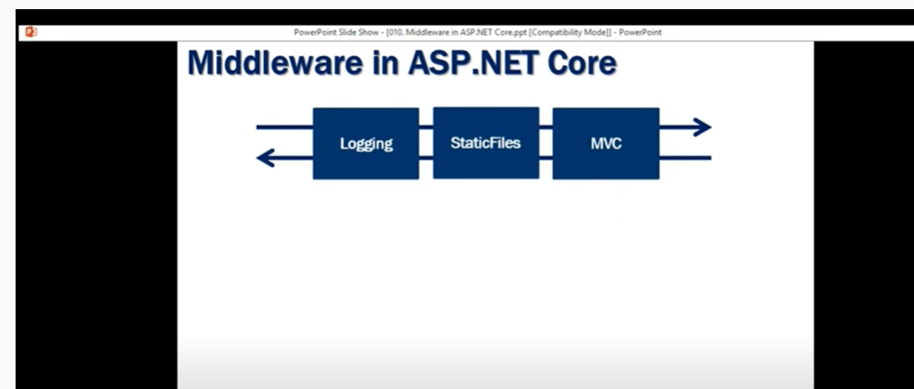here
we have 3 middlesware logginf,static files,MVC this is the pipeline
first logging receives the request from web serevr and then logs the times and then send to next middleware static files may be static files contains images,json… suppose particular for this request if this middlware doesn’t have anything then it will just pass to next middleware then MVC do all the actions and send back to static files and again send to logging and then last to web server to client.
https://www.youtube.com/watch?v=nt6anXAwfYI&list=PL6n9fhu94yhVkdrusLaQsfERmL_Jh4XmU&index=11

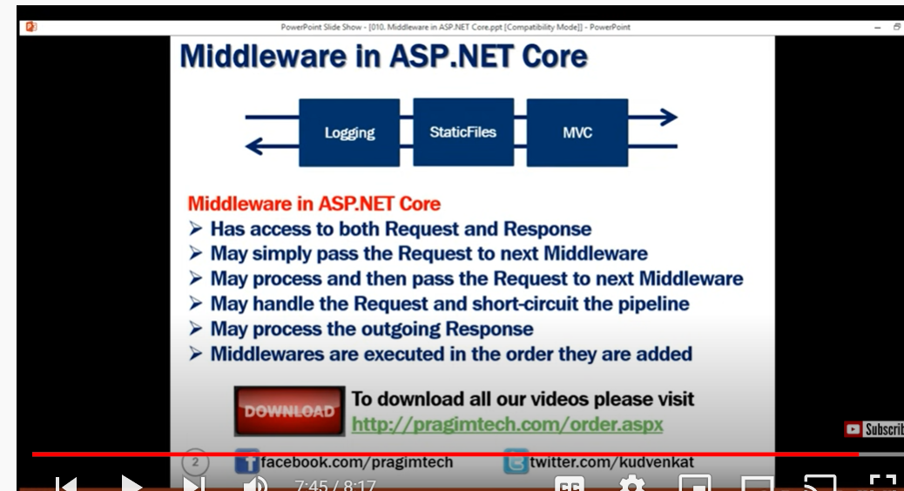H

in startup file
Configure and configure services
https://www.tutorialsteacher.com/core/aspnet-core-startup#:~:text=The%20ConfigureServices%20method%20is%20a,you%20want%20to%20use%20it.

Dependency Injection
AddSingleton()
created once and used evrywhere in application
AddTransient()
each time it will be requested
Addscoped()

